SDMdata Installation Instruction
Author: Minyi Huang
Email: huang.m.y@163.com

INTRODUCTION
SDMdata is a web-based software tool to easily collect occurrence data from the Global Biodiversity Information Facility (GBIF) and check species names and the accuracy of coordinates (latitude and longitude). It is an open source software (GNU Affero General Public License/AGPL licensed) allowing anyone to access and manipulate the source code. SDMdata is available online free of charge from <https://github.com/howl-anderson/SDMdata>.
We emphasize that web-base is browser-based web architecture. In present, we cannot set an official website allowing global users to use it for technology and fund reasons. But when users install their own SDMdata in their computer as a server, the SDMdata will work as a normal web-based application. Generally a researcher team only needs to install SDMdata software in one computer as servers; other team members can access SDMdata through network from their own computer (Desktop, laptop or tablet computer). Users can access SDMdata from anywhere with a correct network connection, all data can be accessed from the local host, or users can be limited to project team members.
We provide a virtual machine image, and an instruction to guide users to use the virtual machine server step by step the installation instruction of SDMdata. Users can download server image from <https://github.com/howl-anderson/>.

INSTALL GUIDE

Install to UNIX/Linux/Mac OS
See install file in Code (https://github.com/howl-anderson/SDMdata/blob/master/document/setup/install.md).

Install to Windows
For technology reason, Windows cannot run SDMdata directly, so using virtual machine is a good choice.

Install virtual machine
General there are two famous virtual machine software: VMware player and Virtualbox. Because Virutalbox is not so good in our test on windows, we recommend to use VMware player. VMware player is a desktop virtual machine software, free for personal use.
We recommend you to use VMware player version 6.0.5 which supports 32bit and 64bit windows system. You can download it from
https://my.vmware.com/web/vmware/free#desktop_end_user_computing/vmware_player/6_0|PLAYER-605|product_downloads
Then you install VMware player into you computer or driver.

Import SDMdata server image
1) You can download server image from https://bitbucket.org/howl-anderson/sdmdata-server-image. You can get 14 Zip files, and then uncompress them; you will see “SDMdata_serve_demo_i386.ova” (the server image).
2) Open your WMare player, and then you can see the interface.
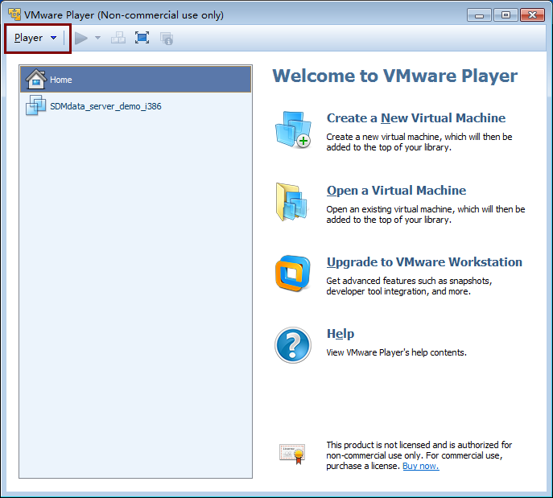
3) In the upper left corner of the interface (already marked with red rectangle), there are main menu.
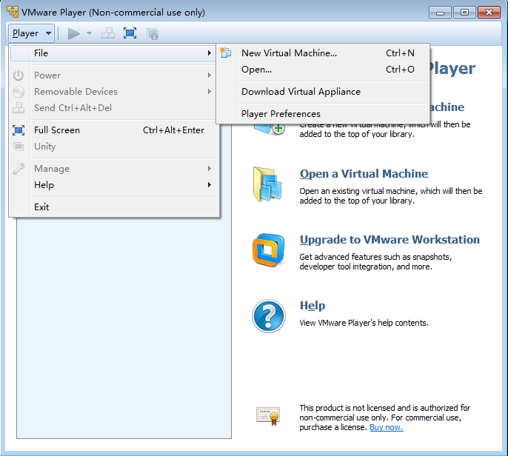
5) Click “open”, then choose the flie “SDMdata_serve_demo_i386.ova” (the file name depends on the place where your image file location is from), the interface like below.
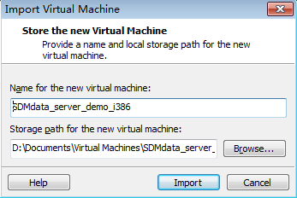
4) Now please pay attention to your storage path for the new virtual machine (already marked with red rectangle)
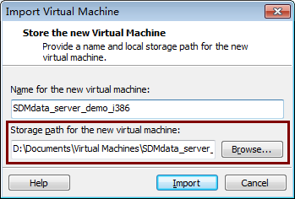

the properties of local disk must be NTFS not FAT32 or FAT16 (The reason is that server image has a large disk file which is more than 4GB. NTFS can support it while FAT32 or FAT16 can not for their max support file size is 4GB). You should ensure the installation software disk capacity is no less than 8GB. Then you can choose import, you can see
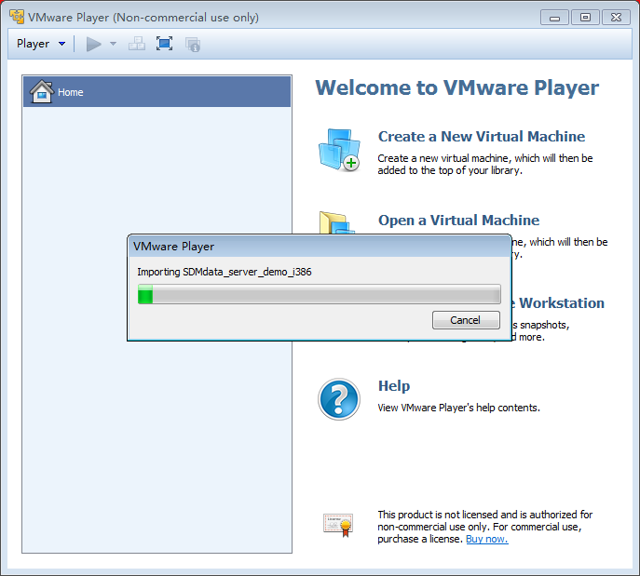
Now please wait patiently, the progress may spend a few minutes, during the progress of import, a VMware player window will pop up,
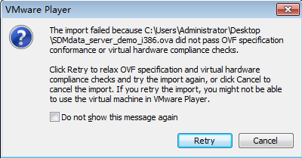

You need click the buttom “Retry” (the reason is that VMware player give a warning because our server image is built by using vitualbox which is not completely compat with VMware player).

Start SDMData server
1) After finishing, you can see the interface
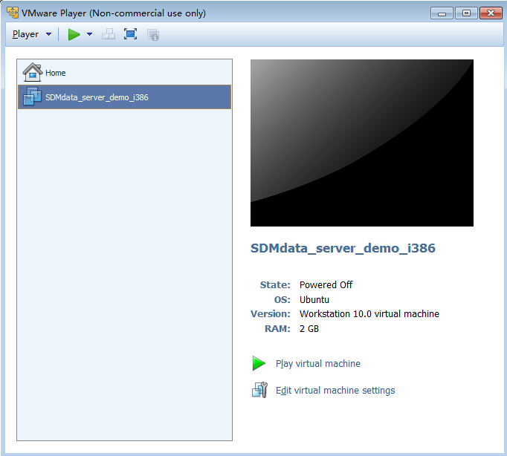
2) Now you click “play virutal machine” (already marked with red rectangle)
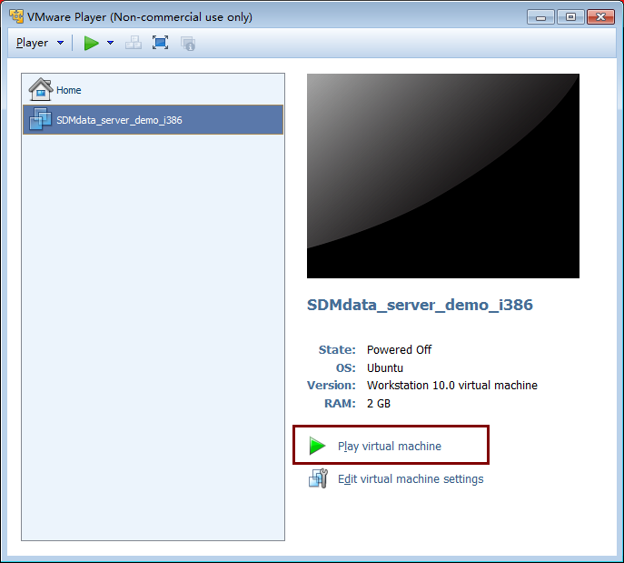
3) Then a window interface may jump out
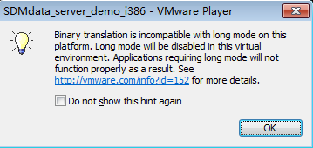
4) You need click “OK”, this is a incompate warning. Different machine have different numbers of warning (one or not, so just click “OK”).
5) SDMdata Server will start like below:
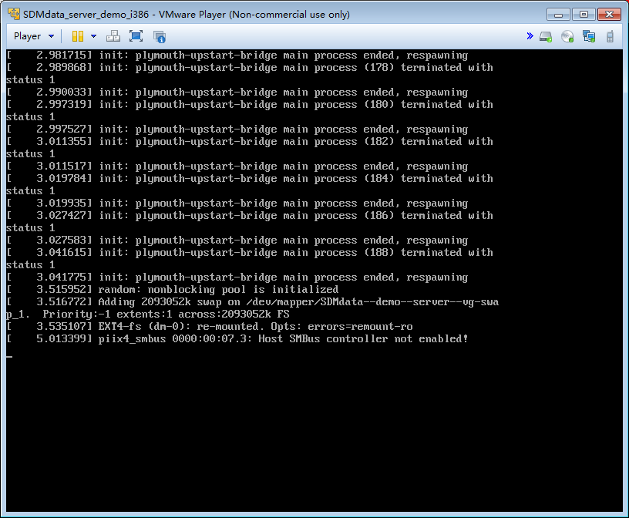
6) During the progress, you may see

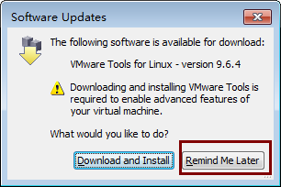
7) VMware player asks you whether you want intall tools to enchance guest operation system.
you should choose remind me later (because SDMdata does not need install VMware tools).
8) OK, you have finished all installation, then you can use SDMdata.

Using SDMdata
1) When server booting is done, you will got login interface
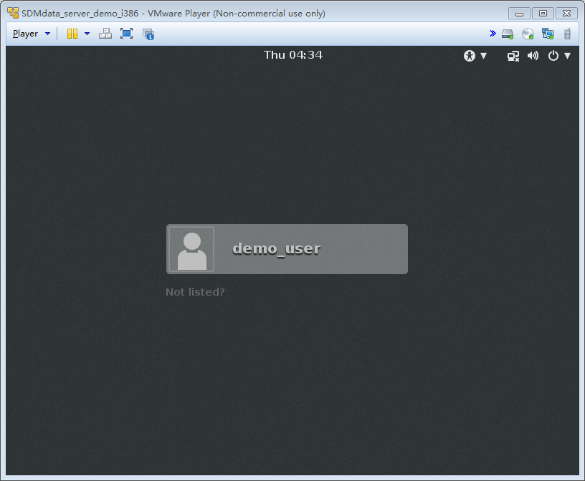
2) Click the “demo_user”, then enter password. The password is the same to the user name “demo_user”
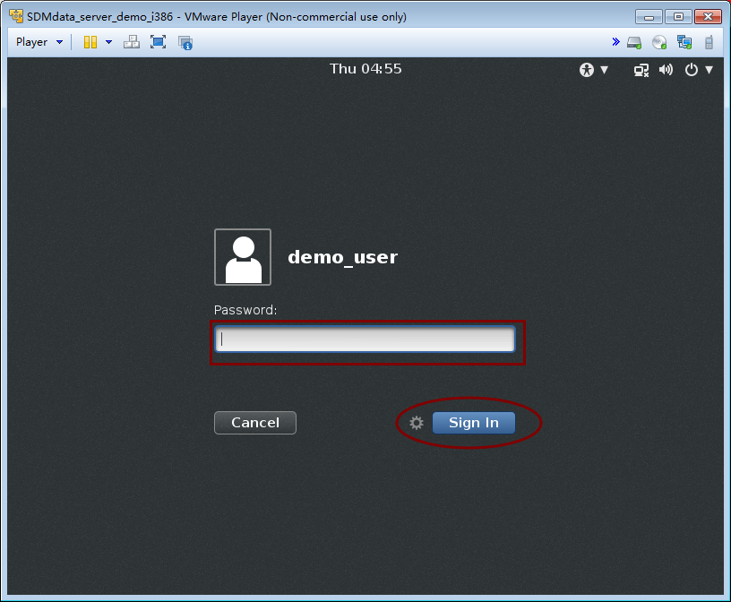
Pay attention that the mouse must in the server interface not your windows interface.

3) In the desktop you can see SDMdata application icon. Double click it to open SDMdata in Firefox (browser).
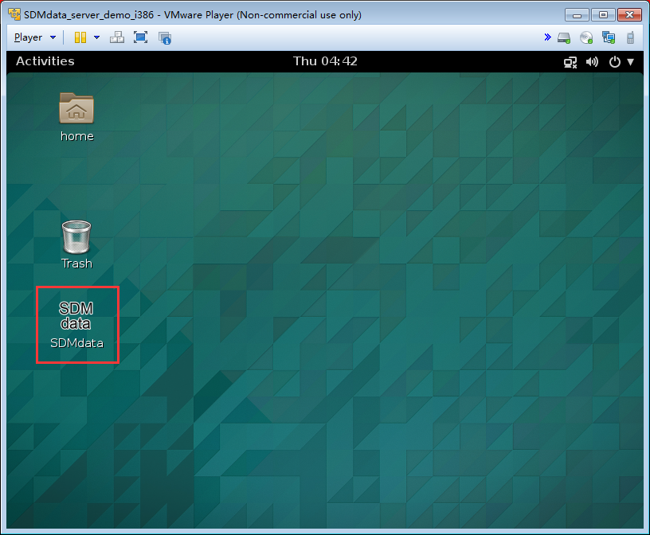

4) The SDMdata interface (Already login, user name and password are “admin”)
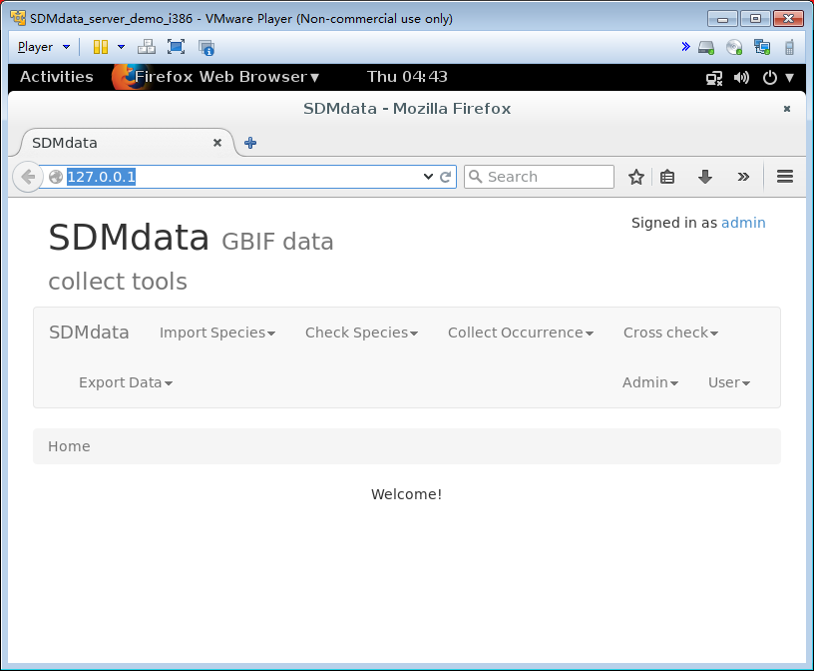
5) Then, you can use SDMdata according to operating instruction.

Technology about SDMdata server image
SDMdata server image is built from Vitualbox, and server operating system is based on Ubuntu server 14.04.1 with desktop environment Gnome shell. SDMdata server application is already set to auto start when system booting. Desktop shortcut will auto open Firefox to go to SDMdata server website.
Currently SDMdata server image is about 1.4GB size. Among them, Operation system is 800MB, SDMdata is about 600MB (SDMdata core is less than 10M, but the global country border are huge size, it is about 600MB).

